Micro/Nano 1x2 Mechanical Optical Switch

Kuang-Chao Fan ¹, Wu-Lang Lin ², Tien-Tung Chung ³, Hung-Yu Wang ⁴,
Long-Pong Wu ⁵,
¹ Professor, Department of Mechanical Engineering
National Taiwan University
fan@ccms.ntu.edu.tw

Abstract
This paper presents the design, fabrication, and tests of a miniature 1x2 mechanical type optical switch, which components are fabricated by precision machining and MEMS technologies. The packaging and alignment are integral processes utilizing the CCD image processing technique and PZT-stages controlled technique in association with the optimization software enabling the fiber to fiber alignment to low optical loss requirement. First, we produced a fiber holder and a V-groove by MEMS technology and used a relay as the input fiber switching actuator. Through proper mechanism design the fiber positioning error can be reduced to below 0.1μm. After optimized alignment process, the results presented the insertion loss could be controlled to ch1: 0.8dB, ch2: 1.4dB at switching time of 5ms. The reliability tests demonstrated the insertion losses are ch1: 0.04dB, ch2: 0.02dB after 10,000 cycle times, and ch1: 0.024dB, ch2: 0.006dB throughout 100 switch times after 1,000,000 cycle times. The developed 1x2 optical switch largely reduces the physical size to 1/2~1/3 in comparison with traditional mechanical optical switches, and the cost is only about 1/10 ~1/20 of the MEMS type optical switches. The advantages of this innovative optical switch are: small size (only about 20×16×7.5mm${}^{3}$), low-cost (only about US$10), high reliability, cross-talk≦-80dB, and automatic alignment.
Keywords: optical switch, fiber-to-fiber, image process, MEMS, alignment, package.

1. Introduction
Because of the popularization for Internet network and personal communication, the huge demand of the optic fiber network causes double growth at the speed of every nine months in average. The technology of DWDM (Dense Wave Length Division Multiplexing) enables coupling and transmitting signals of different light wavelengths in one single fiber. It, therefore, can easily boost several dozen to hundred times the capacity of transmission of optic, and it is the best way to expand the bandwidth of network. If treating the fiber optic communications network as a highway, the data flow being compatible to the traffic flow, then DWDM can be regarded as an increase of the road width (namely the bandwidth of the network). In case the distribution between the data flow and bandwidth is poor, it will cause the bottleneck for communication. Therefore, it needs the component of optical switch to make the best use of DWDM as the moderate distribution of data flow [1]. Optical switches play an important role in fiber optic communication for mapping wavelength from input ports to appropriate output ports based on their destination. Future trend will focus on the signal switch in optical domain at the node, path protection, and add/drop accessibility in order to increase the processing speed and maintain optical transparency. Hence, the population of optical switch is one of the keys to the future DWDM network development. Conventional optical switches used optic-electro-optic (O-E-O) type [2]. In this type, optical signals from the input fiber will firstly convert to electronic signals, which then through electronic converter switch to the required output channel. Passing through an EO converter, the output optical signals can then couple to output fiber. The devices of this type, however, have several drawbacks. For example, they require expensive optic-electro conversion devices. Insertion loss and cross talk are usually high. Also, the electronics bottleneck constrains the growth in capacity of optics for further bandwidth demand. The all-optic (optic-optic-optic, O-O-O) switching design is potentially capable of eliminating these disadvantages [3]. Consequently, it is suitable for the next generation of the optical switching technology.
Concerning the O-O-O types of the optical switch, the mechanical type still dominates the market. The proportion of various mechanical types of optical switch is around: prism type 84%, MEMS type 7%, and moving-fiber type 9%, respectively [4]. Although they are all efficient and available in the market, from the size and cost consideration, however, there are still some rooms to improve. This study has developed the smallest and cheapest 1x2 mechanical type optical switch. Its physical dimension is only 20×16×7.5 mm³ and its direct cost is only about 10 US dollars. Comparing to some existing prism types, such as DICON 1x2 optical switch (size in 67×23×16 mm³) and JDSU 1x2 optical switch (48.36×18.14×8.86 mm³), this miniature innovated optical switch is only about 1/3~1/10 of their sizes. Moreover, due to the elimination of expensive collimators and prisms the direct cost of this new optical switch can be reduced to about 1/5~1/10 order. Although the MEMS type has similar feature of small size, such as DICON 1x2 (20.83×12.7×7.21 mm³), but it needs complicated and expensive fabrication equipment. Our optical switch costs about 1/10~1/20 relatively. For the moving fiber type of current optical switch, such as Hitachi product (with size of 28×15.6×8.3 mm³), our size is about 1/2~1/3 and cost around 1/5~1/10 comparatively.
The characteristics of these types are to switch data flow without optic-electro (O-E) conversion. However, the optic fiber network system is getting more complicate, many traditional mechanical types of optical switch are difficult to meet the requirements of growing up capacity and the BELLCORE standards, especially in the cost consideration. Hence, it is a future inevitable trend to overcome the bottleneck of the so called "last-mile" by using the Micro/Nano precision technologies for developing new generation optical switches. The said Micro/Nano technologies may include precision machining, MEMS fabrication, micro packaging and fiber alignment with PZT stages and precision metrology.

2. Design of a Mechanical 1x2 Optical Switch
There are several types of the optical switch, such as traditional mechanical prism optical switches [5], MEMS optical switches [6], Liquid crystal optical switches [7], Acoustics-Optic optical switches [8], Holographic optical switches [9], Thermal-Optics optical switches [10], etc. They could all meet the requirements from the fundamental theories. In, practice, however, optical switches have to adapt to various environments, especially the ambient changes. During the all year round, all parts are deformed because of the non-uniform temperature condition. It causes the misalignment of optical axes between the input fiber and output fibers. In this study, not only the precision packaging and alignment tasks have to be coped with, the stability due to temperature change is also an important issue to be considered in the switch design. Some design aspects are addressed in the following.

2.1 Design principles of the switch mechanism
A novel 1×2 micro/nano mechanical optical switch is designed which is based on the direct fiber-to-fiber principle, as shown in Fig. 1. For structural simplicity, low cost, and low power consumption, this design eliminates some conventional parts, such as the collimators, turning mirrors, and prisms [11]. The input fiber is mounted onto a V-groove and switched by a simple mechanical relay, and the output fibers are firmly held by a fiber holder. Both the V-groove and the fiber holder can be fabricated by MEMS process in order to ensure its accuracy.

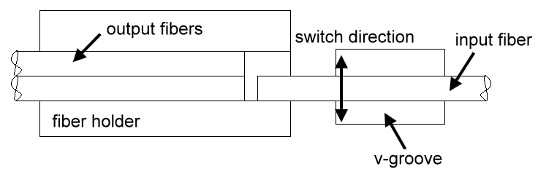

Fig. 1 Fiber-to-fiber switch configuration
There are several advantages of this novel design: (1) compared to the traditional optical switches, it omits the collimators and prisms so as to reduce the device size and cost, (2) the MEMS fabrication process for the V-groove and the fiber holder is easy and low cost, (3) the direct fiber-to-fiber configuration needs only the near field co-axial alignment technique, which promises less optical loss than other light bending configurations, (4) simpler configuration yields to easier assembly process to high precision, (5) employing computer- and image processing-aided alignment processes the throughput can be faster, and (6) using the low thermal expansion INVAR steel for the housing (size: 20×16×7.5mm³) and the ANSYS software analysis to compensate for the thermal deformation (not detailed in this report, please refer to [12]). This structure is sturdier to suit various environments. The mechanism design of this novel optical switch is illustrated in Fig. 2.

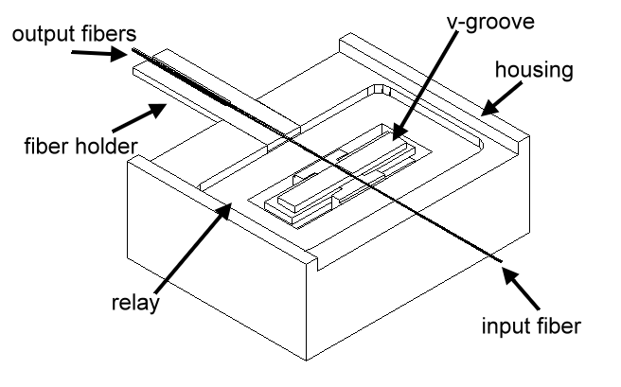
Fig. 2 Micro/Nano 1x2 optical switch

2.2 Design of actuator
We use an industrial miniature relay(14×9×5 mm³), made by Omron Co, as the actuator to switch the input fiber to required positions. Fig. 3 shows the switching principle. The switching time of relay can be made within 10 ms. It can be seen from Fig. 1 that the side walls of the fiber holder (12*3*0.5 mm³ with U-groove of 125μm in depth and 250μm in width, as shown in Fig. 3) play the role as a stopper of the switching input fiber. From the parameter design of the switching mechanism the variation of correct positioning of the input fiber can be significantly reduced to about 10 times by the stopper based on the lever design. In addition, using finite element analysis to design the dimensions of all components, the optimized elements with material selection for thermal compensation can theoretically yield to the misalignment error below 0.314μm under environment temperature change from 70${}^{0}$ to -5${}^{0}$C [12]. The final fiber to fiber positional thermal drift can be fully compensated. This paper does not describe detailed design analysis of this part.
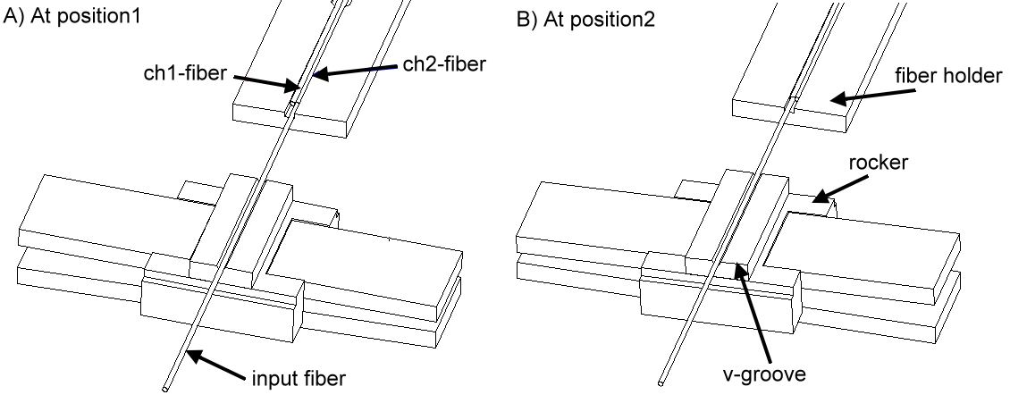
Fig. 3 The switching mechanism

2.3 Error reduction of switch mechanism
The mechanical relay has inherent switching error of positioning with the amount of about 10μm at the end point (δp), as shown in Fig. 4(a). Based on the lever principle this amount can be reduced to 2μm at the end point of the y-arm (δ_{f}), which is the location of the V-groove. Again, as shown in Fig. 1, the V-groove positioning error can further be reduced to below 0.1μm after the second trigonometric relationship of the fiber stopper pivot mechanism. As shown in Fig. 4(b), if there is no stopper in the fiber holder, the lateral misalignment $δ_{2}$ (=δ_{f}) of the input fiber will cause the same amount to the output fiber because they are straight and parallel. The effectiveness of the stopper acts like a second lever mechanism and, due to the ratio of arms (a/b about 1:10), the lateral misalignment could be significantly reduced in proportion.

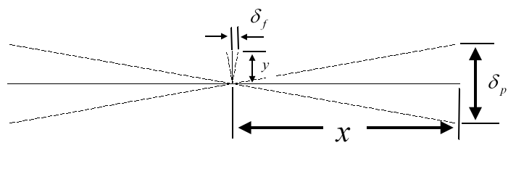
( a )
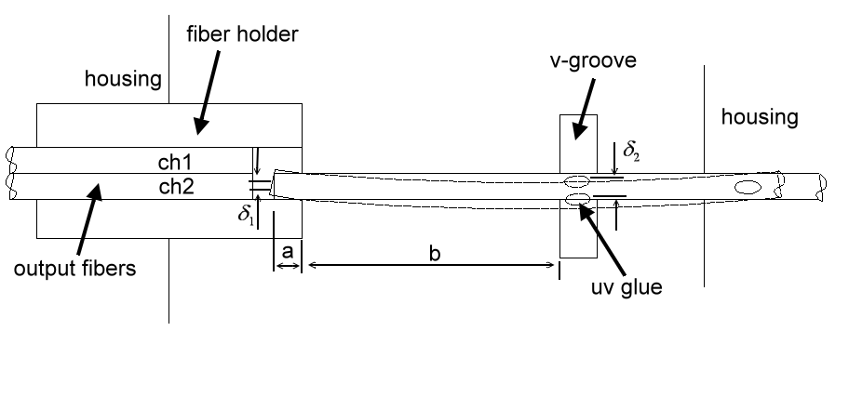
( b )
Fig. 4 Principle of geometrical error reduction

3. Computer-assisted Automatic Alignment System
The initial fiber-to-fiber alignment is a difficult task that must allow two output signals strong enough to meet the BELLCORE specifications. Manual work is laborious and subject to harm the eyes. This study developed the CCD image processing technique in association with two sets of six-axis PZT stages to achieve this goal. The system block diagram is shown in Fig. 5. The alignment system consists of a 1550nm Laser source, an optical switch, an image system, two six-axis PZT stages, and an optical detector. The image system detects the initial fiber to fiber position to about 10 μm in axis alignment. The optical detector outputs its signals to a Power Meter through a RS232 serial port to the PC. Applying the developed LABVIEW software the PC can output analog signals via a D/A converter to drive the PZT stages so as to adjust the fiber positions. The optimization software installed in the PC is then activated to fine tune the stage positions so as to minimize the optical loss during switching. During the assembly process the fiber holder module (consisting of fiber holder and two output fibers) and the housing module (consisting of the input fiber, relay, V-groove and housing) are operated to align the light. The insertion loss between ch1 and ch2 will by all means affected by the dimension accuracy and roughness of the fiber holder. The actual positions of ch1 and ch2 will be slightly deviated from their ideal positions. Therefore, using the CCD image and PZT stages to control the light search program in order to achieve the minimum insertion loss is a dynamic and optimum means. Finally, using the UV glue to adhere and fix the fibers [13] to accomplish the alignment and package processes of the 1x2 optical switches. Fig. 6 shows the experimental setup of the developed automatic packaging and alignment system. Fig. 7 shows the picture of the developed miniature 1x2 optical switch of which the physical dimensions are only 20×16×7.5 mm³.

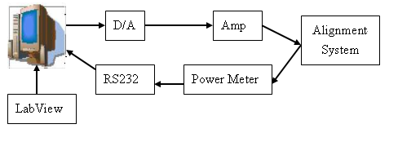

Fig. 5 Block diagram of the alignment system
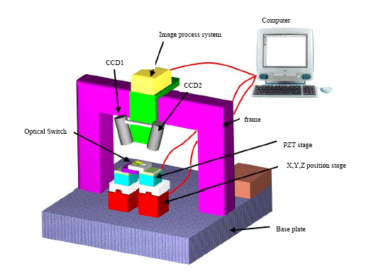
Fig. 6 Experimental setup of packaging and alignment processes

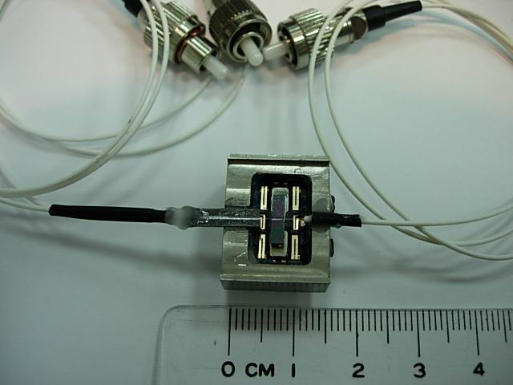
Fig. 7 Photo of the developed 1x2 optical switch
This study utilized the LABVIEW software as the system developing tool. During the alignment and reliability tests some real time information can be viewed. There are four areas displayed on the PC screen, as shown in Fig. 8. The first area lists the controlled parameters including voltage, time, and channel. The second area displays the optical loss diagram, which is used to feedback control the PZT stages to compensate the errors. The third area displays the captured fiber to fiber image. The fourth area displays the parameters of image processing, such as threshold for image binarization, intensity enhancement, and filtering. Alignment process is conducted by two stages for position adjustment: the rough stage by CCD detection and the fine tune stage by optical signal output.
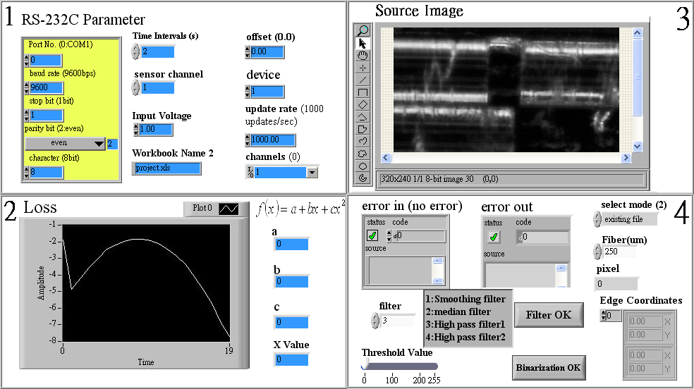
Fig. 8 Screen of real time display

4. Alignment Tests
Optical fibers in use have the following specifications: single-mode fiber outer diameter 125μm, core diameter 9μm, zero degree of the fiber tip angle, non anti-reflection coating. Alignment tests include the effects of optical loss due to fiber to fiber axial separation, lateral misalignment and title angle misalignment [14-15].

4.1 Fiber to Fiber Axial Separation
This is to control the PZT stage to let the fiber to fiber tips separate from the touch position. The optical loss will be raised as the axial distance increases. Fig. 9 shows the experimental results.
Fig. 9 Axial separation vs optical losses

4.2 Lateral Misalignment
This is to separate two fibers in lateral direction from the optical axis. It was found the optical loss increased significantly as the lateral misalignment increased. This lateral misalignment is more serious than the axis separation, as shown in Fig. 10.
Fig. 10 Lateral misalignment vs optical loss

4.3 Title Angle Misalignment
This is to tilt the input fiber relative to the output fiber with an increment of one degree each time. Experimental results show that it is also very sensitive to the optical loss, as shown in Fig. 11.
Fig. 11 Tilt angle misalignment vs optical loss

5. Reliability Tests
After the packaging and alignment processes were completed, the reliability tests were carried out. The complete system was placed in a mini environment chamber in which the temperature and humidity can be computer controlled. The goals are to test the insertion loss (IL) and long time reliability loss (RL). Setting a constant temperature of 22 ℃ and humidity of 50%, Fig. 12 shows the best insertion loss of ch1 is 0.8dB and ch2 is 1.4dB with the switching time of 5ms for a 50-minute run. Fig. 13 shows the insertion loss after the fiber holder module and the housing module have been UV glued and solidified. The initial insertion losses are: ch1=1.97dB and ch2=3.14dB. Comparison to the best insertion losses as given in Fig. 12, extra insertion losses due to this packaging process are found with ch1=1.17dB and ch2=1.74dB. This is a reasonable phenomenon [16-17] and should be overcome in the future. Fig. 13 also demonstrates that the reliability tests of the optical losses after 10,000 cycle times are ch1: 0.04dB and ch2: 0.02dB. After 1,000,000 cycle times the optical losses throughout 100 switch times are ch1: 0.024dB, ch2: 0.006dB, as shown in Fig.14. The insertion losses are all a little bit larger than the allowable value of 1dB as specified by the BELLCORE standard. It is because that the current fibers in use are all non anti-reflection coated and non 8-degree edge cut at the tip. The equipments for those processes are expensive and are not affordable by us. It is believed that after these processes the final insertion loss could fall into the BELLCORE requirement. However, the stability of long time reliability tests has shown very promising results with only very small amount of optical loss variation. Fig. 15 shows the wave forms of the switching time.

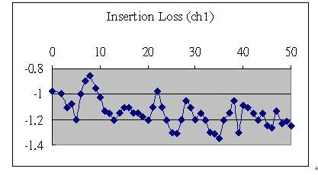
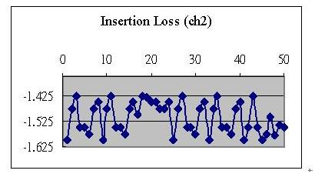
Fig. 12 Insertion loss tests of ch1and ch2

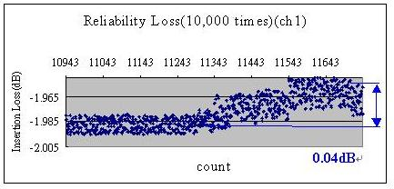

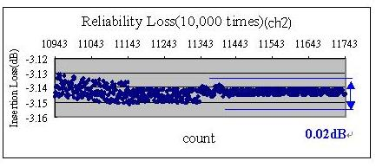
Fig. 13 Reliability test of ch1 ch2 during 10,000 cycle times
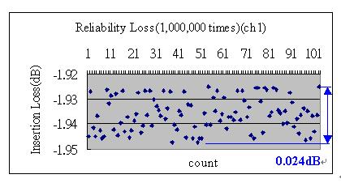
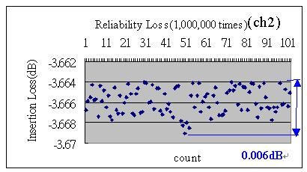
Fig. 14 Reliability loss of ch1 ch2 after1,000,000 cycle times
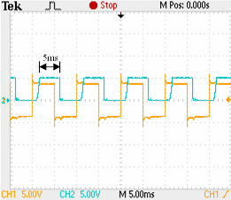
Fig. 15 On/Off responses vs. the switching time

6. Conclusion
Utilizing the micro/nano technologies, a miniature mechanical type 1x2 fiber to fiber optical switch has been develop successfully. The switch size is only 20×16×7.5mm. Its structure is simpler than most of the existing optical switches. Experimental results showed the insertion loss could be controlled to ch1: 0.8dB, ch2: 1.4dB with switching time 5ms, and cross-talk≦-80dB. The reliability tests demonstrated the optical losses are ch1: 0.04dB, ch2: 0.02dB after 10,000 cycle times, and ch1: 0.024dB, ch2: 0.006dB throughout 100 switch times after 1,000,000 cycle times. The developed 1x2 optical switch largely reduces the physical size to 1/2~1/3 in comparison with traditional mechanical optical switches, and the cost is only about 1/10 ~1/20 of the MEMS type optical switches. The advantages of this innovative optical switch are small size, low-cost, high reliability and automatic alignment.

REFERENCES
[1] J. J. Pan, “Advanced fiber optic components for DWDM communications”, IEEE/LEOS Summer Topical Meeting San Diego, CA. USA (Jul. 1999) 115-116.
[2] M. A. Bourouha, M. Bataineh and M. Guizani, “Advances in optical switching and networking: past, present, and future”, IEEE SoutheastCon2002 (Apr. 2002) 405-413.
[3] P. O. Hedekvist, M. Karlsson and P. A. Andrekson, “Fiber four-wave mixing demultiplexing with inherent parametric amplification”, Journal of Lightwave Technology Vol. 15 (Nov. 1997) 2051-2058.
[4] G. I. Papadimitriou, C. Papazoglou and A. S. Pomportsis, “Optical switching: switch fabrics, techniques, and architectures”, Journal of Lightwave Technology Vol. 21, No. 2 (Feb. 2003) 384-405.
[5] R. Kishimoto, “Design of a single-mode fiber optical switch”, Trans. I.E.I.C.E (C) J68, No. 12 (1985).
[6] A. Q. Liu, X. M. Zhang, V. M. Murukeshan, Q. X. Zhang, Q. B. Zou and S. Uppili, “An optical crossconnect (OXC) using drawbridge micromirrors”, Sensor and Actuators A 97-98 (2002) 227-238.
[7] Y. Fujii, “Low-crosstalk 2×3 optical switch composed of twisted pneumatic liquid crystal cells”, IEEE Photonics Technology Letters Vol. 5 (Jun. 1993) 715-718.
[8] E. Dai, D. Wu, and A. Xu, “High speed integrated acousto-optic switch with high extinction ratio”, Conference on Optical Fiber Communication Vol. 2 (Mar. 2000) 139-141.
[9] I. G. Manolis, T. D. Wilkinson , M. M. Redmond and W. A. Crossland, “Reconfigurable multilevel phase holograms for optical switches”, IEEE Photonics Technology Letters Vol. 14 (Jun. 2002) 801-803.
[10] S. Toyoda, N. Ooba, Y. Katoh, T. Kurihara and T. Maruno, “Low crosstalk and low loss 2x2 thermo-optics digital optical switch using silicone resin waveguides”, Electronics Letters Vol.36, No.21 (Oct. 2000) 1803-1804.
[11] S. Nagaoka, “Latching type single-mode fiber switch”, Electronics Letter Vol. 26, No. 11 (May. 1990) 744-745.
[12] J. H. Chen, “Thermal deformation analysis and optimum design for optical switches”, MS Thesis National Taiwan University, ROC (2004).
[13] S. G. Kang, M. K. Song, S. S. Park, S. H. Lee, N. Hwang, H. T. Lee, K. R. Oh, G. C. Joo and D. Lee, “Fabrication of semiconductor optical switch module using laser welding technique”, IEEE Transactions on Advanced Packaging Vol. 23, NO. 4 (Nov. 2000) 672-680.
[14] Z. Tang, R. Zhang and F. G. Shi, “Effect of angular misalignment on fiber-optic alignment automation”, Joural of optics Communications Vol. 196 (Sep. 2001) 173-180.
[15] J. Sin, D. Popa and H. E. Stephanou, “Model based automatic fiber alignment”, Proceeding of Fiber Optic Automation Conference San Jose, CA, (Dec. 2002) 415-420.
[16] S.G. Kang, M. K. Song, J. T. Moon, H. T. Lee, S. H. Lee, N.Hwang, S. S. Park, K. R. Oh and K. E. Pyun, “Fabrication of multi-channel tapered optical fiber array package using laser welding technique”, IEEE/ LEOS 10th Annual Meeting Vol. 2 (Nov. 1997) 193-194.
[17] B. Acklin, J. Bellermann, M. Schienle, L. Stoll, M. Honsberg and G. Muller, “Self-aligned packaging of an optical switch array with integrated tapers”, IEEE Photonics Technology Letters Vol. 7, No. 4 (Apr. 1995) 406-408.

微/奈米1x2機構式光開關

范光照¹, 林武郎², 鍾添東³, 王宏瑜⁴, 吳龍朋 ⁵
¹ 國立台灣大學機械工程系 教授
fan@ccms.ntu.edu.tw

摘 要
本文係利用精密加工技術與微機電元件製造技術相結合，研製出小尺寸、低成本與高可靠度之1x2機械式光開關。本光開關運用最佳化理論設計一組創新機構並採用光纖直接對位(Fiber-To-Fiber)之光路傳輸方式，藉由整合CCD影像處理定位與壓電微動平台光纖對位光損耗誤差補償，求出最低損耗值以進行組裝與封裝。首先，利用微機電製程製作光纖定位元件，以Relay當光纖光路切換之致動器，運用了幾何縮小原理將光纖撥切定位誤差降至0.1μm以下。最後，實驗組裝結果證明:最佳插入損耗可達Ch1: 0.8dB、Ch2:1.4dB，切換時間5ms，撥切10,000次之光損耗穩定度為ch1: 0.04dB、ch2 : 0.02dB，撥切長時間1,000,000次後再取值100次之光損耗穩定度為ch1為0.024dB、ch2為0.006dB。本光開關之研製可大幅改善傳統機構式光開關體積大之缺點，體積將大幅縮小為1/2~1/3，並克服微機電式光開關之高成本及低良率之缺點，成本可降至1/10~1/20。本文研製之1x2光開關具最小尺寸(20×16×7.5mm${}^{3}$)、低成本(10美元)、高可靠度及快速對光組裝之特性。
關鍵詞：光開關、光纖直接對位、影像處理、微機電、對光、封裝

